TWO STAGE OTA ASSIGNMENT

DC analysis DC gain plots:

Schematic:

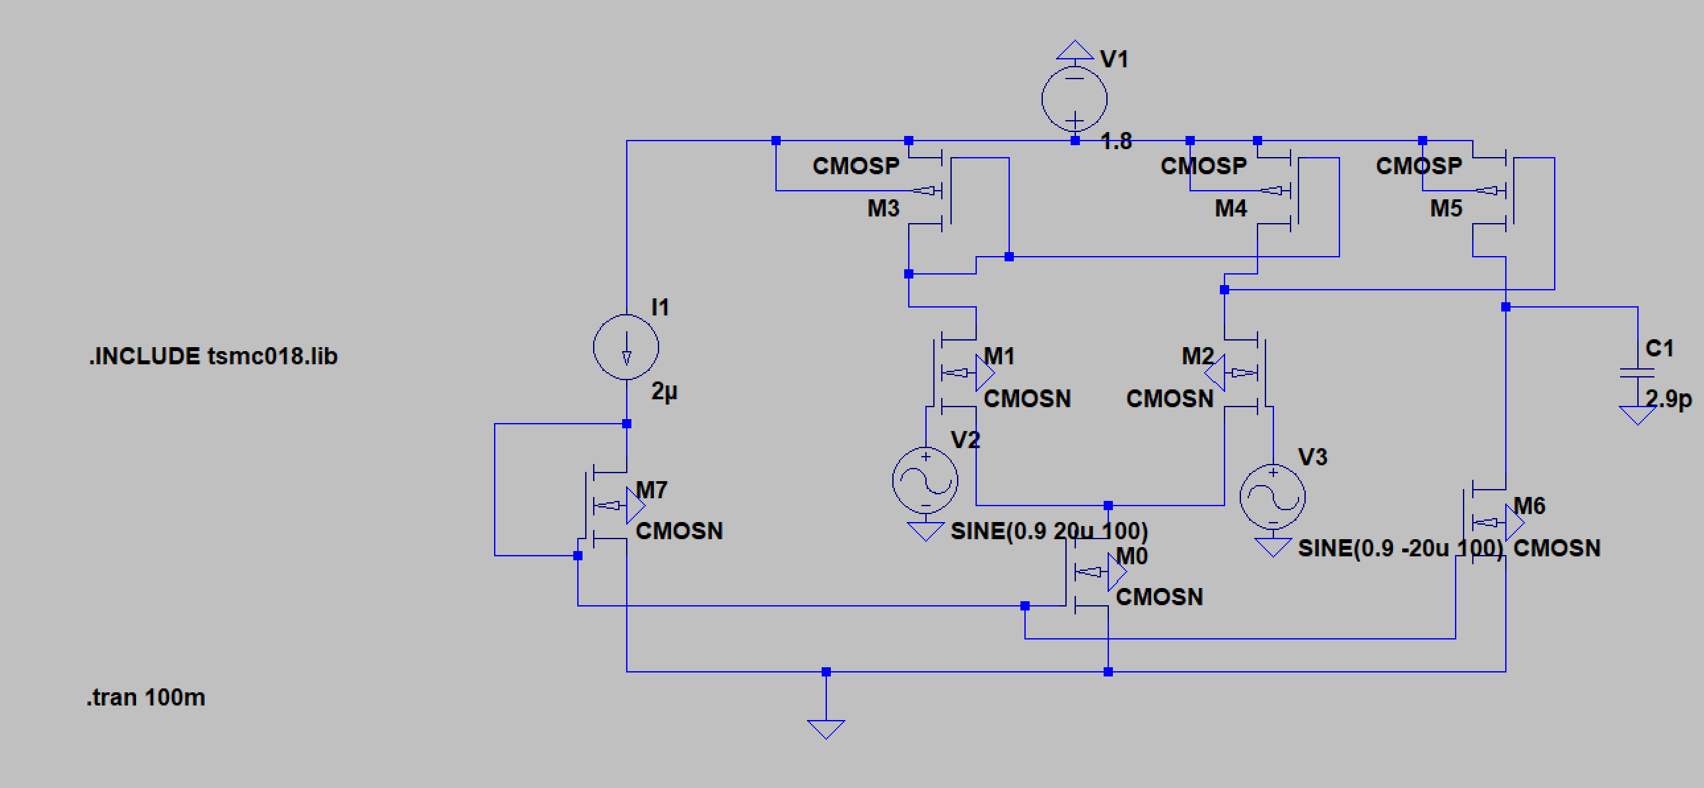

1st stage output

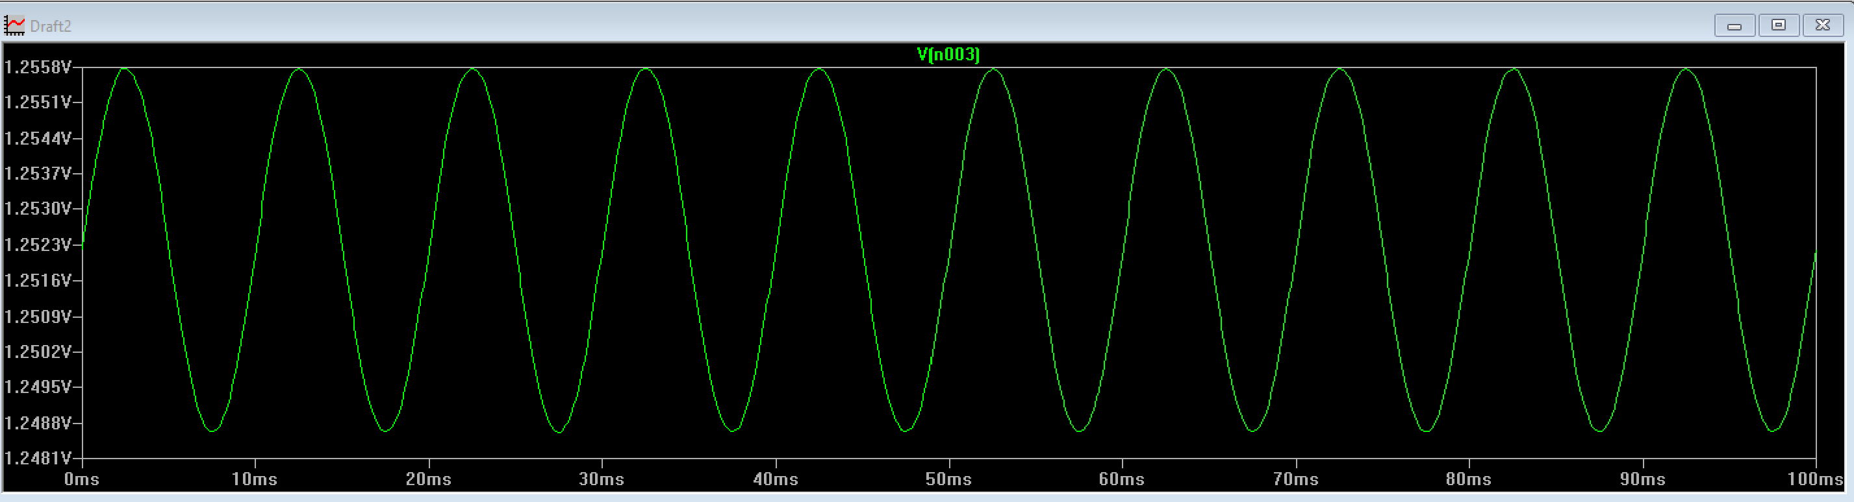

2nd stage final output

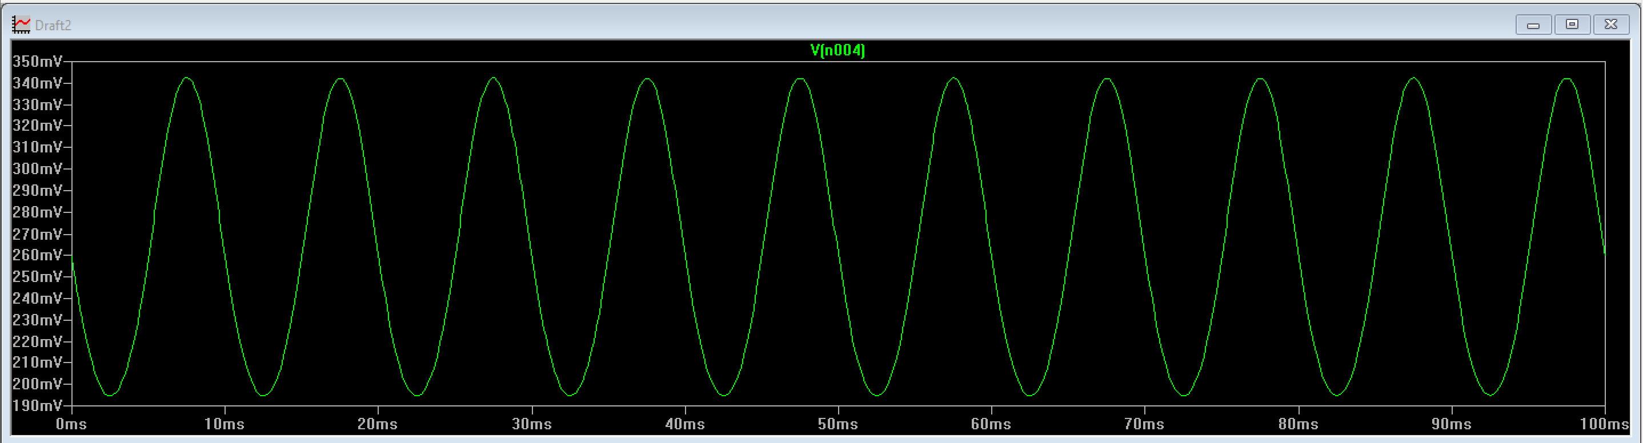

ALL designed values:

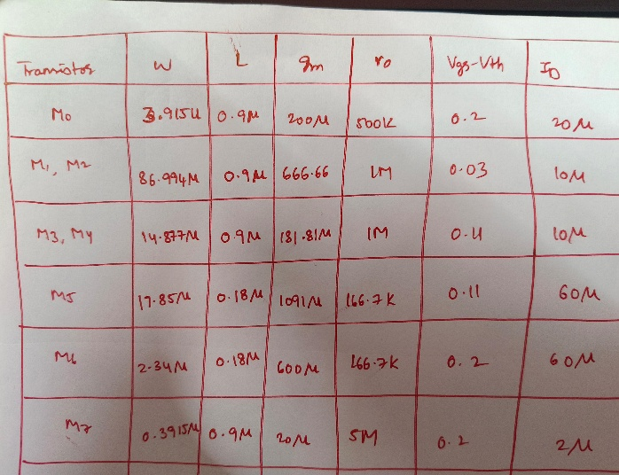

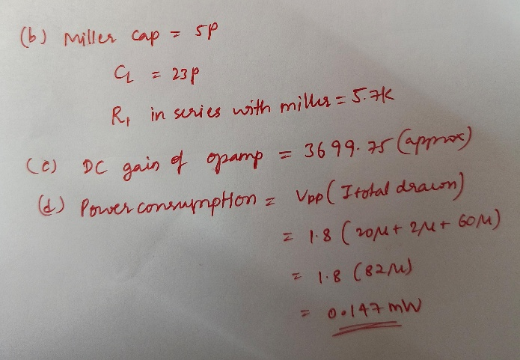

Transient analysis for a step input of 0.2V mag of a two stage ota with feedback

Schematic

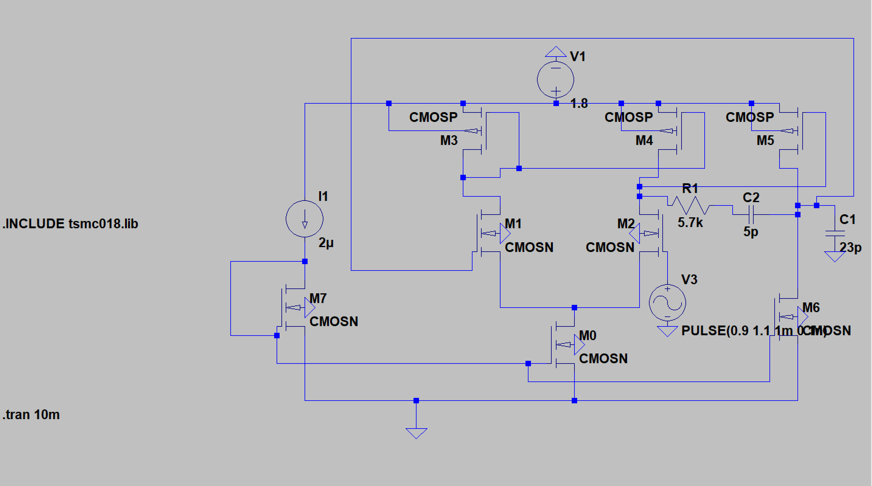

Output

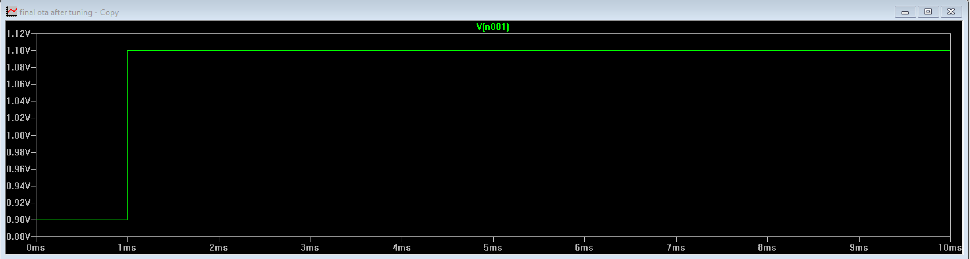

After tuning ,

Final ota schematic:

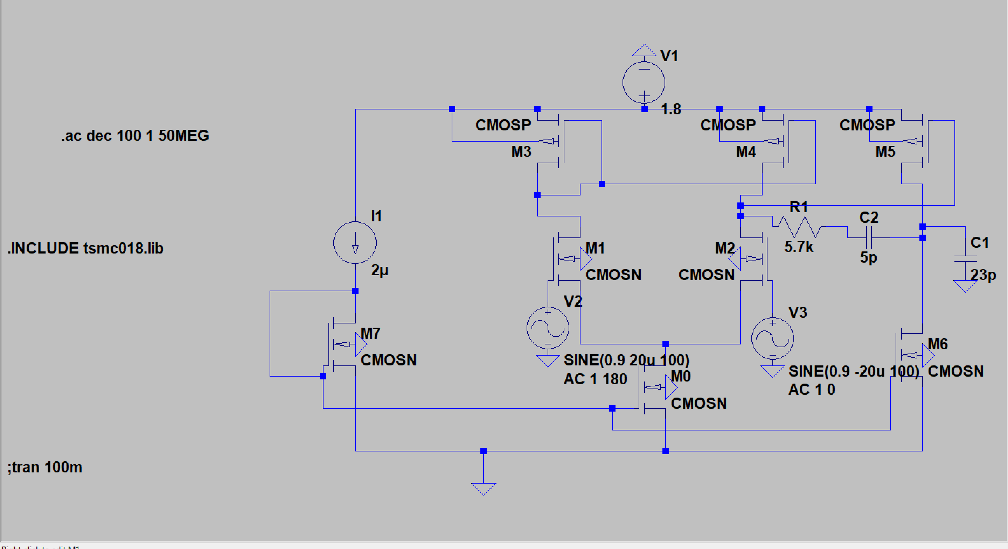

final ota phase margin:

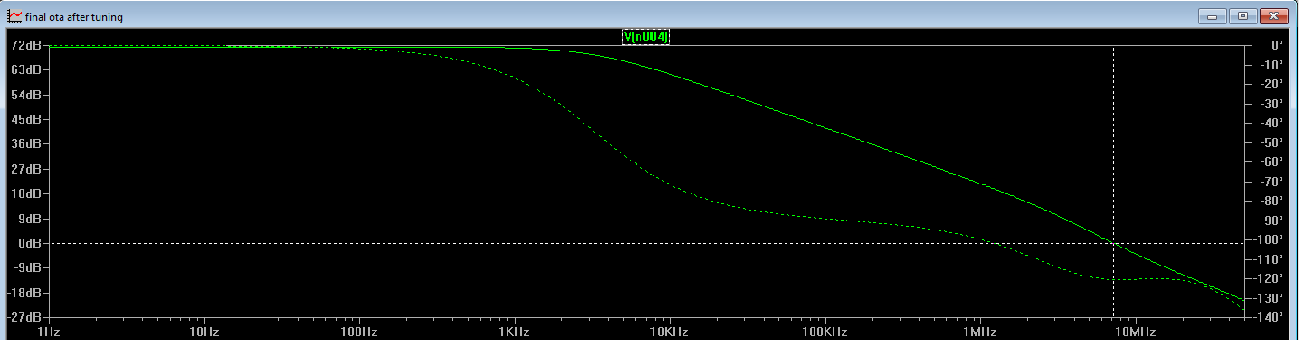

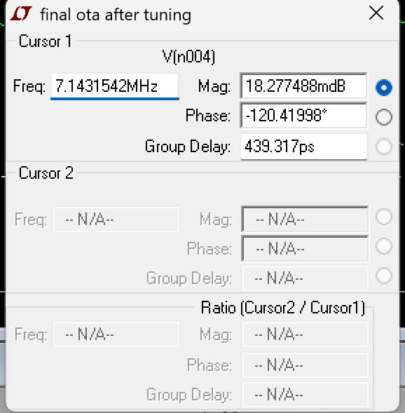 Phase margin= 180-|-120| =60 deg.